Blocked Country Sign-In — Conditional Access
  - SOC Investigation Report | Microsoft Sentinel & Defender XDR | Incident 477

Findings
Time: 2026-10-08 11:45:56 UTC
User: Patricana Mitts
User Account: patricana@hca355.onmicrosoft.com
Source IP: 135.136.39.6
Source Location: Switzerland (CH)
Application: One Outlook Web
Incident ID: 477
Severity: Medium
Detection Source: Microsoft Sentinel
Alert Name: Blocked Country Sign-In - Conditional Access
Conditional Access Policy: Block-Selected-Countries-Lab
Error Code: 53003 — Access blocked by Conditional Access
IP Reputation: VirusTotal 2/92 security vendors flagged the IP; VPN/proxy indicators identified
Incident Status: Resolved
Classification: Informational, expected activity — Security testing

Investigation
On 2026-10-08 at 11:45:56 UTC, the user Patricana Mitts attempted to access Microsoft 365 through One Outlook Web using a VPN connection from Switzerland with the source IP address 135.136.39.6.
Microsoft Entra ID recorded the sign-in attempt as a failure with error code 53003, indicating that the Conditional Access policy blocked token issuance because the sign-in originated from a restricted country.
Microsoft Sentinel detected the blocked sign-in through a scheduled analytics rule and generated an alert in Microsoft Defender XDR under Incident 477.
Further investigation of the source IP using VirusTotal identified VPN/proxy indicators, with 2 out of 92 security vendors flagging the IP. WHOIS information associated the IP with M247 Europe SRL (AS9009), a network provider operating infrastructure in Switzerland. These findings alone do not confirm malicious activity.
The sign-in was part of an authorized security simulation to test location-based access restrictions and SOC detection capabilities. The investigated sign-in was blocked by Conditional Access; the reviewed evidence does not establish unauthorized access from this attempt. Other sign-in sessions were not exhaustively assessed.
The incident was classified as expected security testing activity and resolved.
WHO — User: Patricana Mitts (patricana@hca355.onmicrosoft.com).
WHAT — A Microsoft 365 sign-in attempt from Switzerland was blocked by Microsoft Entra Conditional Access. Microsoft Sentinel generated an alert for the activity.
WHEN — The blocked sign-in occurred on 2026-10-08 at 11:45:56 UTC. Microsoft Defender subsequently generated Incident 477. The incident was resolved on October 8, 2026.
WHERE — The sign-in originated from IP address 135.136.39.6, geolocated to Switzerland (CH), and targeted One Outlook Web.
WHY — The activity was intentionally performed as part of an authorized SOC security simulation to test whether Conditional Access would block sign-ins from restricted countries and whether Microsoft Sentinel would detect the event.
HOW — The test user connected to a Switzerland VPN and attempted to sign in using valid account credentials. Microsoft Entra ID evaluated the sign-in against the configured Conditional Access policy and denied access with error code 53003. The blocked event was recorded in Entra sign-in logs, detected by Microsoft Sentinel, and surfaced in Microsoft Defender XDR.

Recommendations
- Maintain the existing Microsoft Entra Conditional Access policy restricting sign-ins from unauthorized countries. The policy successfully blocked the investigated sign-in attempt.
- Continue monitoring Microsoft Sentinel alerts for blocked-country sign-ins. Review repeated attempts, unusual source IP addresses, and unexpected activity involving user accounts.
- Correlate future blocked sign-in alerts with successful and non-interactive sign-in logs to determine whether an account gained access through another session or location.
- Review suspicious IP addresses using threat intelligence sources such as VirusTotal and WHOIS. Consider VPN/proxy indicators alongside authentication logs rather than treating them as proof of malicious activity.
- Document authorized security simulations and classify related incidents appropriately. Incident 477 was resolved as Informational, expected activity — Security testing. No additional containment was required for the investigated authorized test.

Evidence Screenshots
The following screenshots are ordered to show the blocked authentication, sign-in details, Sentinel detection, threat intelligence review, and final incident resolution. Screenshots are taken from the authorized training environment.
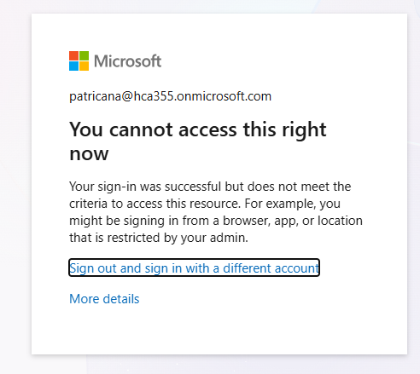
Figure 1. Microsoft 365 access-denied screen after the Switzerland VPN sign-in.
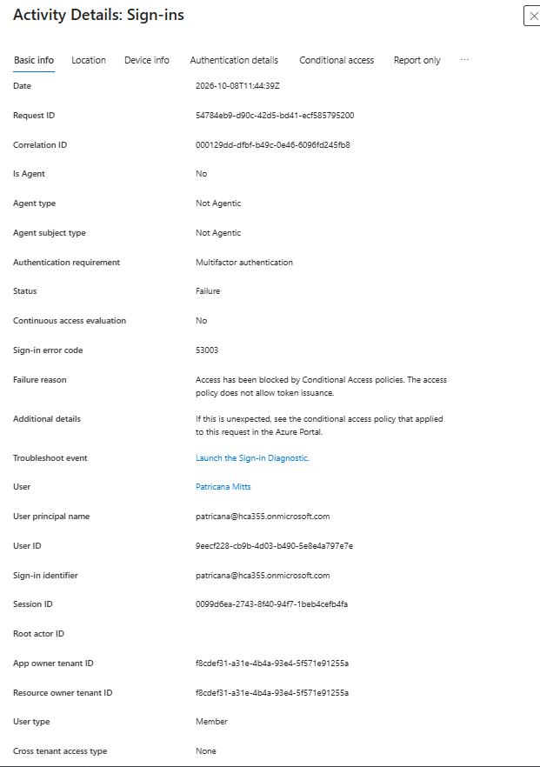
Figure 2. Microsoft Entra ID sign-in activity details for the test account.
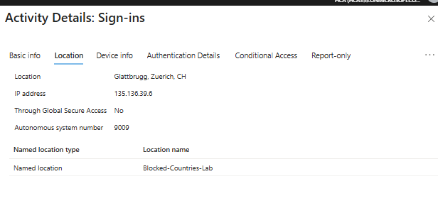
Figure 3. Entra sign-in location: Switzerland, source IP 135.136.39.6, and named location.

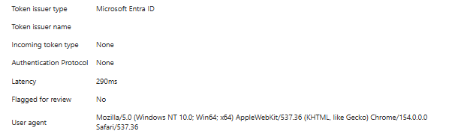
Figure 4. Browser User Agent and token metadata; contextual information only.
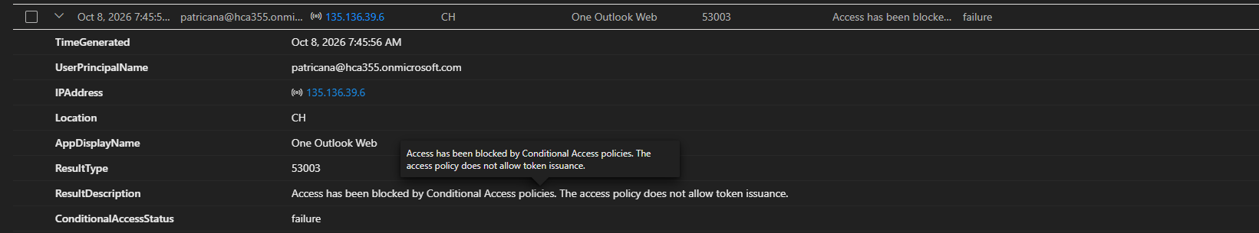
Figure 5. SigninLogs evidence showing error 53003 and Conditional Access failure.

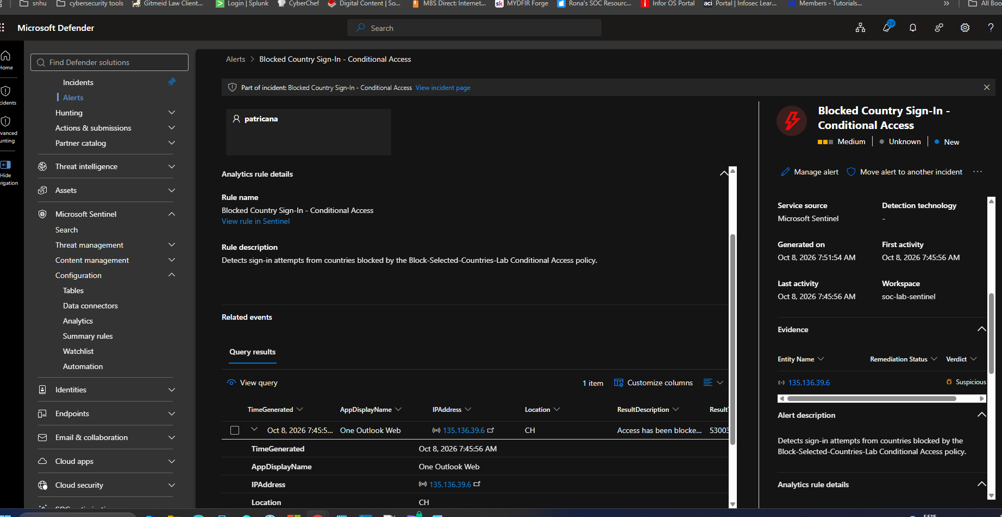
Figure 6. Microsoft Sentinel scheduled detection and matching alert evidence.
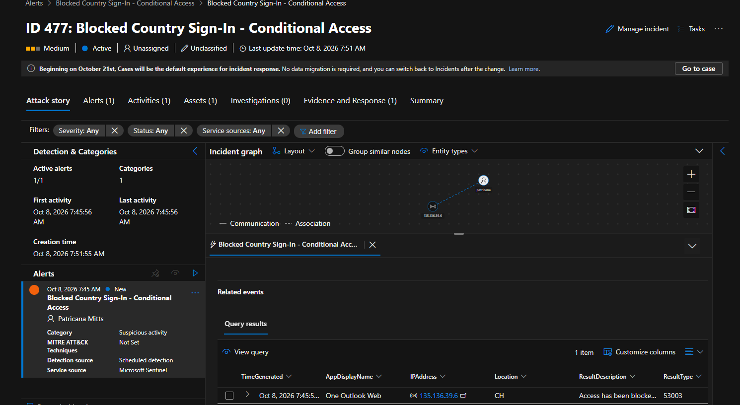
Figure 7. Microsoft Defender XDR Incident 477 and investigated sign-in.

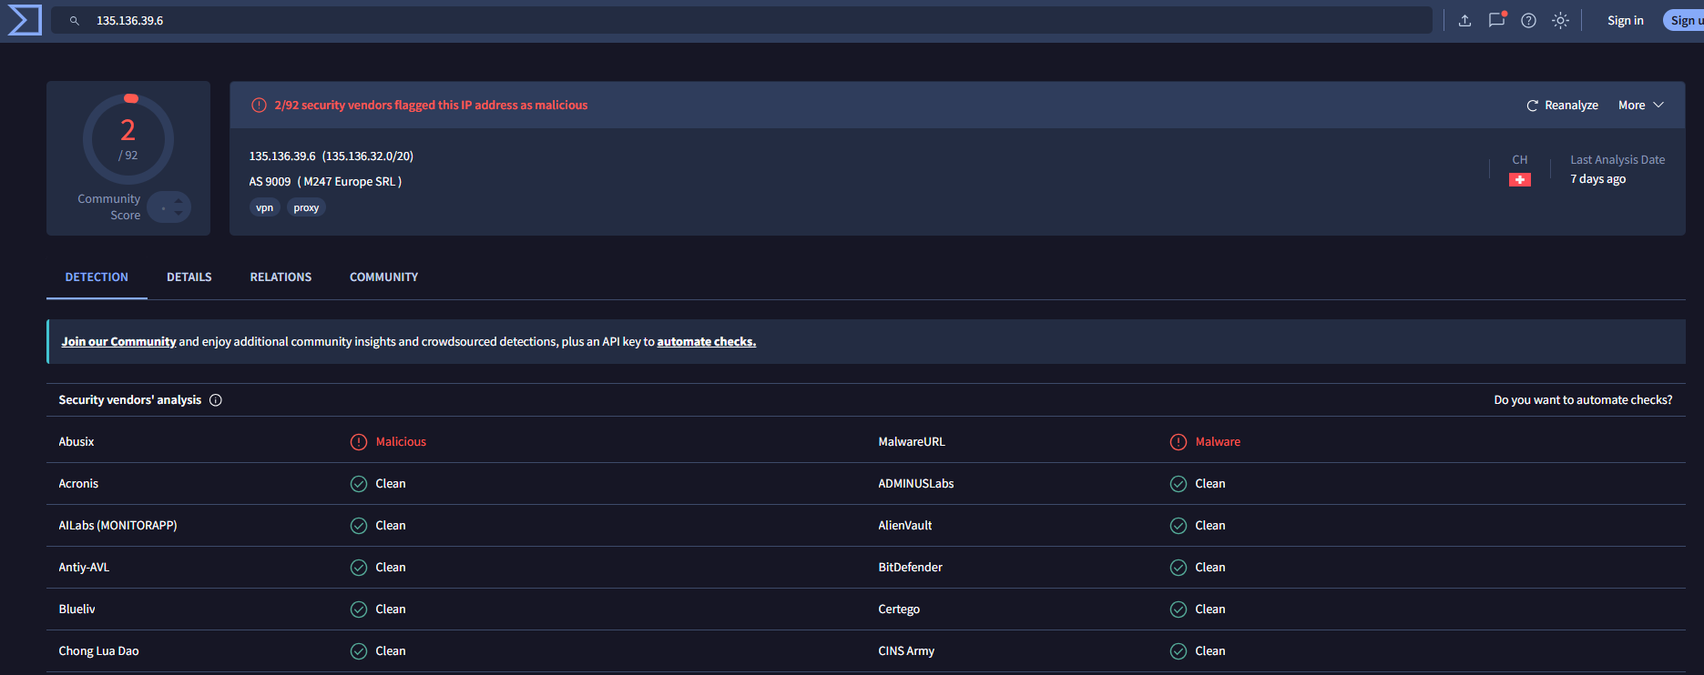
Figure 8. VirusTotal reputation results for the source IP (2/92 detections).

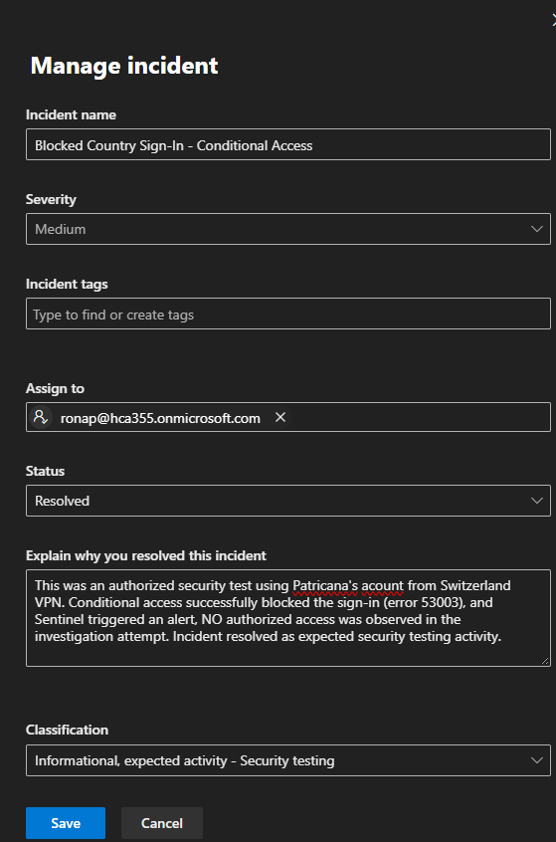
Figure 9. Incident resolution explanation and security-testing classification.
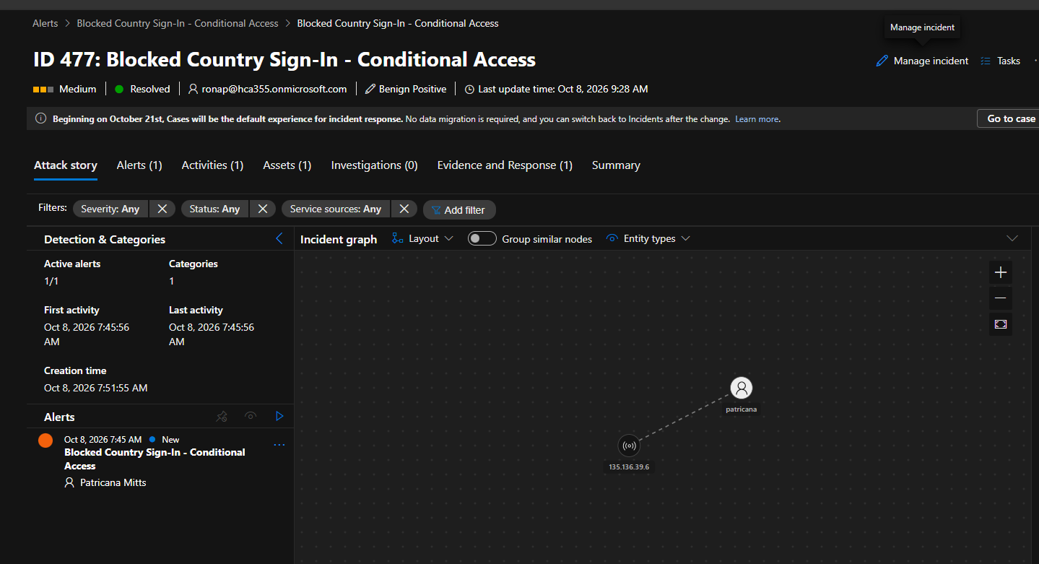
Figure 10. Defender incident status: Resolved.
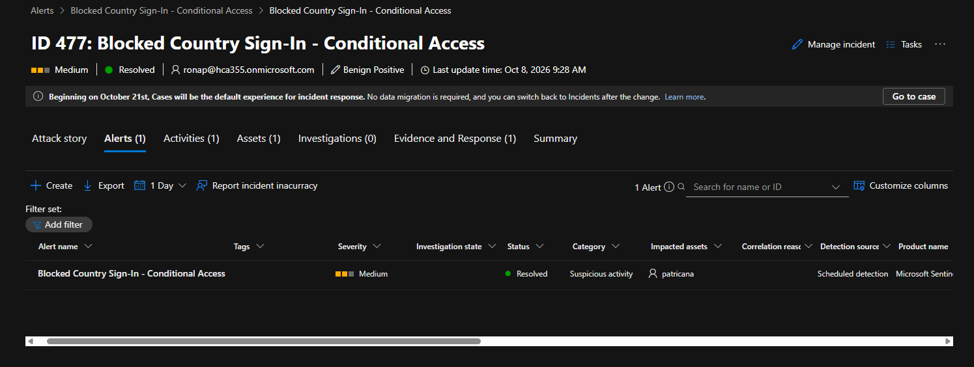
Figure 11. Associated alert status: Resolved.

